1
1– What animals are now extinct?

1. CHOOSE
A. Butterflies. B. Dinosaurs
2– What activities are part of your lifestyle?

A. Exercise and healthy eating. B. I am very happy.
المملكة العربية السعودية |  |  | اسم الطالب/ ......................................
وزارة التعليم
إدارة التعليم بمنطقة |  |  | المادة : انجليزي
مدرسة : |  |  | الزمن :
 |  |  | الصف : السادس فصل ( )
شفهي | تحريري |  |  | المجموع
10 / | 10 / |  |  | 20 /
Top goal3 اختبار الفترة الأولى الفصل الأول - للعام الدراسي 1448– لغة انجليزية –– للصف السادس
اسم الطالب / هـ الفصل /

2. CHOOSE OR
1.5

She has longer hair.
Be quiet.
This is an elbow.

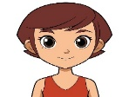

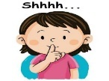


3. DO AS SHOWN BETWEEN BRACKETS
1.5

1- Sharks eat fish. (complete ) ___________ are eaten by _____________.
spoon | bed | tissue | 2 – I use _______ to eat food ( choose )
4. CHOOSE
1

are fed | Is feed | 1. Cats ________ by humans.
passed | will pass | 2- you _______ your exam, if you study hard

3
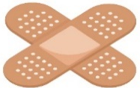 | 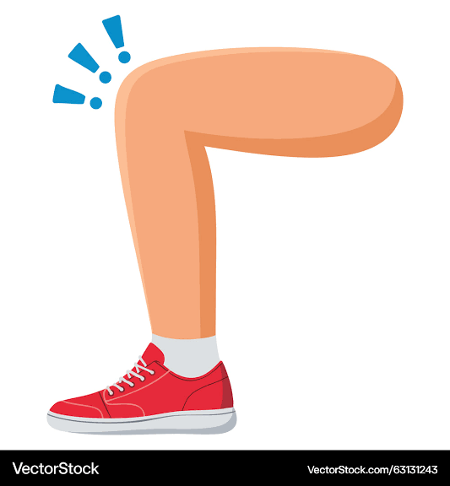 | 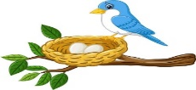 | 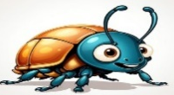 | 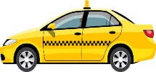 | 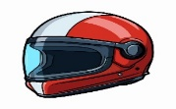  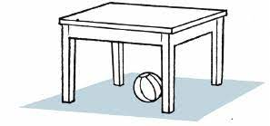
bandage | finger | nest | butterfly | taxi | helmet
medicine | knee | net | beetle | plane | cap
5. CHOOSE
5. CHOOSE
2

Choose the correct letter: ( k - r - g - d ) )

سادس

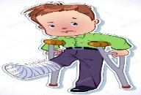 |  |  | 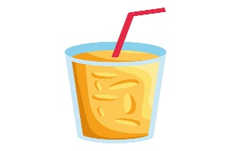
Bro_en leg | The f_r is very soft. | look l_ke | A _lass of juice
c | u | i | g
k | e | u | c

___________________________________________________________________________________________________________________________________________________________________________________________________________________________________
Controlled writing

4

Good luck T.


Kingdom of Saudi Arabia 6th Elementary Grade

Ministry of Education First Term

10
……… Elementary School First Exam - 1448 AH
Name: ………………………………………………………….………………. Class : …………..
- General Questions:
- Choose the correct answer:
1- When something can happen, but not right now.
a- if you want |  |  |  |  | a- in a minute
2- What do you do as a zoologist?
a- I study and look after animals. |  |  |  |  | b- I study and look after cars.
3- Name an animal that lives underwater and has eight legs.
a- A shark. |  |  |  |  |  | b- An octopus.
- Reading short sentence:
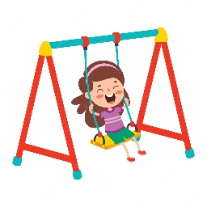
- Read the sentences then match them with the correct pictures:
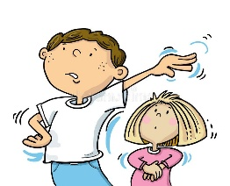 | 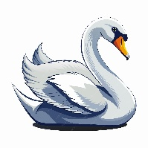 | 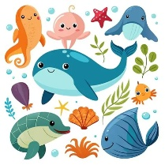
a-_Go away!  b-_Yes! I agree! | a- It is a frog.  b- It is a swan. | a-They live in the ocean.  b-They live in the desert. | a-_She is on the swing.  b-_She is climbing a tree.

III. Grammar:
- Choose the correct answer:
- The jungle ………………. tigers hunt.
- am where |  |  | - is where |  |  |  |  | - are where
- Dinosaur bones are ………………… by scientists.
- study |  |  | - studied |  |  |  |  | - studying
- What did you …………………. for breakfast this morning?
- eat |  |  | - ate |  |  |  |  | - eating
V. Vocabulary:
- Choose the correct answer:
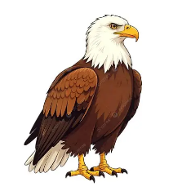 |  | 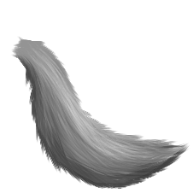 |  |  |  | 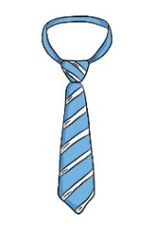 |  |  | 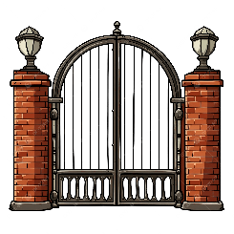
- eagle  - chameleon |  | - wing  - fur |  |  |  | - tie  - backpack |  |  | - gate  - glass
- Fill in the blanks with the words from the box.
agree – at the moment – pond
1- ………………………: Another way to say “right now”.
2- ………………………: a small area of water where fish live.
VI. Orthography:
- Choose the correct missing letters:
  jour__alist |  | 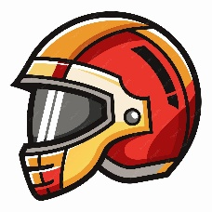  h__lmet |  |  |  | 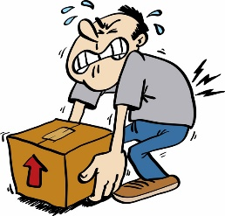  hea__y |  |  | 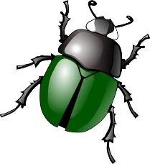  bee__le
m | n | i |  | e |  | v | f |  | t | d

BEST OF LUCK
Ms. Tahani Al-Ghamdi



Kingdom of Saudi Arabia
Ministry of Education
……..Education Directorate
………………… School
English Language
elementary Grade 6th
period Exam
…………….\20
الاسم: الصف:

……\ 4 marks

General questions

A.Answer the questions
I get to school by bus. |  | What living things can you find? | 1
In a minute. |  | Where does a zoologist work? | 2
He works in zoos. |  | Can you help me with my homework? | 3
I can find birds, animals, and insects. |  | How do you usually get to school? | 4

Controlled Writing
……\ 1 marks
A-reorder.
1-the desert \ live \ Camels \ in

a-in camels the desert live. b-Camels live in the desert.

……\ 4 marks

Reading short sentence
 | 1-Tang is on the swing.( )
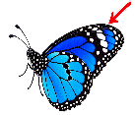 | 2- Most animals with wings can fly. ( )
A-Put ( ✔ ) or ( X )
B. Choose the correct answer.
c-pencil | b-bag | a-glass | 1-Please give me a …………….. of water.
c-swim | b-write | a-touch | 2-Make sure you don’t…………wild animals.

……\ 4 marks

Grammar
A-Choose the correct answer.
c- acting | b- acts | a- act | 1- I am …………. on stage now.
c- widest | b-wider | a -wide | 2- Amazon is the …………… river.
c-see | b-saw | a-seen | 3-Butterflies aren’t…….. in cold weather.
c-who | b-what | a-where | 4- The jungle is ………. tigers hunt.

Vocabulary
A.Choose the correct word under each picture.
……\ 5 marks

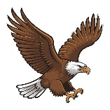 | 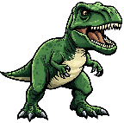 |  | 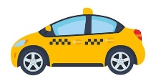 | 
eagle | dinosaur | tiger | taxi | helmet
insect | beetle | heavy | bus | gate

Orthography
……\ 2 marks

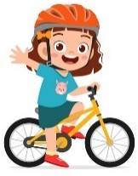
A- Fill in the missing letter.

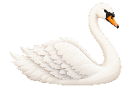

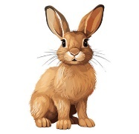
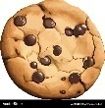
1-coo…….ie
( k – v - n )
2- ….…ie
( m – f – t )

( s – t - o)
3-fu…ry
( g – h - r )

4- s…...an
( e – w – f )

( s – t - o)

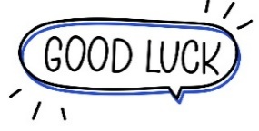
Your teacher:

Your teacher …..:…………………………….

المملكة العربية السعودية
وزارة التعليم
ادارة تعليم .........
مكتب نعليم …….
مدرسة ............
اختبار الفترة الاولى
الصف السادس الابتدائي
الوقت: 25 دقيقة

الاسم ثلاثي: | ……………………………… | الفصل | 6 /.... | الدرجة | / 20
1-Match with the correct sentences: : …..\ 4 marks
You will break it. |  | Are bones eaten by dogs? | 1-
Yes, I did. |  | Which animal live under water? | 2-
Sharks |  | Did you ever get hurt? | 3-
Yes, they are. |  | What will happen If I fall on my elbow? | 4-

2- WRITE THE NUMBER OF THE SENTENCE UNDER ITS PICTURE: …..\ 2 marks
- It can fly. 2- The dinosaur is an extinct animal.

3- They are colored peppers 4- My leg is broken
(A)  ( ) | (B)  ( ) | (C)  ( ) | (D)  ( )

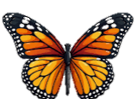
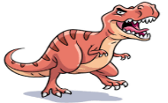
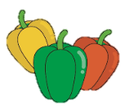
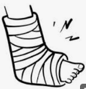

3- Read the text and answer the questions with ( T ) or ( F ) …..\ 4 marks
3- Read the text and answer the questions with ( T ) or ( F ) …..\ 4 marks
Animals live in different environments. Fish and sharks live in the ocean. Camels live in hot, dry deserts and can survive without water for many days. Birds and tigers live in forests. Some animals live in cold places, while others live in warm areas. Every animal needs food, water, and shelter to survive. Each animal has a safe home.
- Fish and sharks live in the ocean. ( )
- Camels live in forests. ( )
- Birds and tigers live in forests. ( )
- Every animal needs food, water, and shelter to survive ( )

4. Grammar: Choose the correct answer: … \ 3 marks
1. | We …….. better, if we rest well.
 | A | feel | B | felt | C | feeling
2. | Dinosaur bones are ……….. by students
 | A | studying | B | study | C | studied
3. | I need ………… salt on my salad.
 | A | many | B | a few | C | a little

5- Write the correct word under its picture: …..\ 5 marks
shkar | maj | krof | pusocto | ifken
………………………… | ………………………… | ………………………… | ………………………… | …………………………

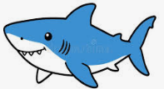
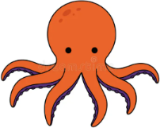

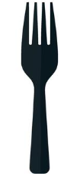
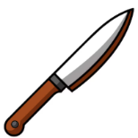

 | 6 – Choose the missing letter: …..\ 2 marks
sw_n |  | str_wberry | _lives | d_nosaur
i / e / a |  | i / o / a | e / i / o | o / e / i

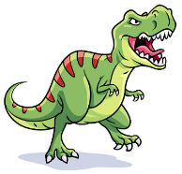
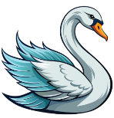

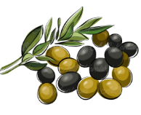

End of Questions



First Period Exam – Top Goal 3

مدرسة :
الاسم | الفصل | شفهي | تحريري | المجموع
 | / | 10 / | 10 / | 20 /
Choose the correct answer:
/ 1
1– What animals are now extinct?

A. Butterflies. B. Dinosaurs
2– What activities are part of your lifestyle?

A. Exercise and healthy eating. B. I am very happy.

____________________________________________________________________________________________________
Choose or :
/ 1.5
It is a big dinosaur. |  | She has a long hair. | This is an elbow .
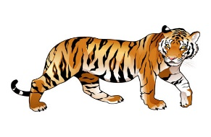 |  | 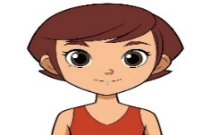
______________________________________________________________________
/ 1.5
1- Sharks eat fish. (complete ) ___________ are eaten by _____________.
spoon | bed | tissue | 2 – I use _______ to eat food ( choose )
Do as shown between brackets :

Choose the correct word:
/ 1
are fed | Is feed | 1. Cats ________ by humans.
passed | will pass | 2- you _______ your exam, if you study hard

/ 3
Choose the correct word:

bandage | finger | nest | butterfly | taxi | helmet
medicine | knee | net | beetle | plane | cap
Choose the correct letter to fill in the blank:
/ 2
Bro_en leg | The f_r is very soft. | look l_ke | A _lass of juice
c | u | i | g
k | e | u | c

Good luck T.
Controlled writing

4

