
المملكة العربية السعودية الصف: الخامس الابتدائي
وزارة التعليم الفترة الدراسية: الثانية
المدرسة الابتدائية ............. العام الدراسي 1447 هـ
الزمن: ساعتان
الاختبار النهائي لمادة اللغة الإنجليزية – الصف الخامس الابتدائي – الفترة الدراسية الثانية (الدور الأول) لعام 1447 هـ
عزيزتي الطالبة:
- استعيني بالله ثم اجيبي عن الأسئلة
- فضلا تأكدي من كتابة اسمك الرباعي ورقم الجلوس
- الإجابة باللون الأزرق فقط

اسم الطالبة رباعيا
رقم الجلوس: |  | الصف: الخامس الابتدائي | المادة: اللغة الإنجليزية
اليوم: | التاريخ: / 1 / 1448 هـ

المدققة وتوقيعها | المراجعة وتوقيعها | المصححة وتوقيعها | الدرجة كتابة | الدرجة رقما | السؤال
 |  |  | فقط |  | General  Questions
 |  |  | فقط |  | Guided  Composition
 |  |  | فقط |  | Reading  Short Sentence
 |  |  | فقط |  | Grammar
 |  |  | فقط |  | Vocabulary
 |  |  | فقط |  | Orthography
 |  |  | فقط | 40 | المجموع


Kingdom of Saudi Arabia 5th Elementary Grade
Ministry of Education Time: Two Hours
………..Elementary School Number of papers: 3 . Final Exam – Second Term – 1447 AH
- General Questions:
/ 7
  - Match the questions with the correct answers:
A |  | B
1. What were you doing at 6 o’clock? |  | I need fishing rod for fishing.
2. What items do you need for fishing? |  | I have used a car and a bus.
3. Have you bought a new umbrella? |  | I was sleeping.
4. What kind of transportation have you used? |  | No, I haven’t.

  - Choose the correct answer:
1- What are the people in stories called?
a- places | b- characters
2- Did you have fun on your trip?
a- Yes, I was. | b- Yes, I did.
3- What do kings and queens wear that is made of gold?
a- belt | b- crown
/ 7
- Guided Composition:
  - Complete the paragraph about Your Last Outdoor Activity. Use the words from the box.
felt – camping – clothes – weekend – cooked – tent – took
My Last Outdoor Activity
Last ……………, I went ……………with my family. We put up a …………… and …………… food outside. I …………… a flashlight and warm …………… with me. It was fun and I …………… happy.

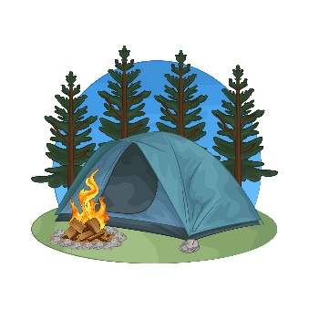

- Reading Short Sentences:
/ 7


  - Read the sentences then match them with the correct pictures:
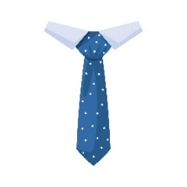 | 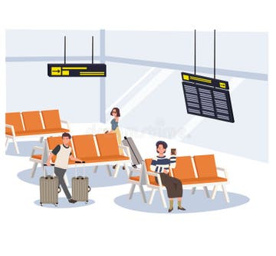 |  | 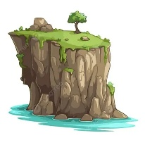
a- It’s a spotted tie.  b- It’s a striped tie. | a-_It is a platform.  b-_It is a terminal. | a-_The plane lands.  b-_The plane takes off. | a-_That is a cliff.  b-_That is a forest. | a-_It is a cartoon.  b-_It is a horror story.

  - Read the passage and answer the questions below.
Little Red Riding Hood
Little Red Riding Hood had a basket of food for her sick grandma. She walked through the forest and met a big, hungry wolf. The wolf ran to Grandma’s house and tried to eat her. A kind woodcutter came and saved both Little Red Riding Hood and her grandma.
- Choose the correct answer:
1.Who was Little Red Riding Hood visiting?  a- her friend.  b- her grandma.  c- her teacher. | 2. What did she carry in her basket?  a- toys  b- food  c- clothes

- Grammar:
/ 7
  - Choose the correct answer:
    - The belt (is make – is made – are made) of leather and metal.
    - We have (take – took – taken) a tour before.
    - The plane hasn’t departed (just – yet – already).
    - They didn’t (see – saw – seeing) the snake.
    - (Who – When – While) Jack was rafting, his raft hit a rock.
    - He was (watch – watched – watching) a movie.
    - How about (see – saw – seeing) a horror movie?

- Vocabulary:
/ 7
  - Write the words under the correct pictures:
rope – necklace – play – traffic – wool
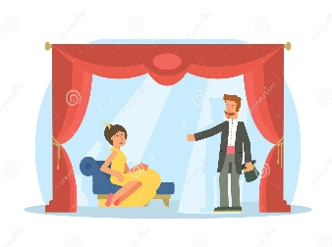
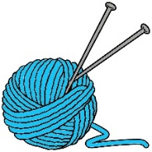 |  | 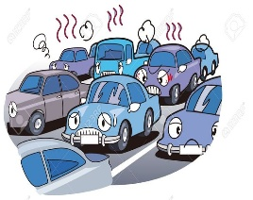 | 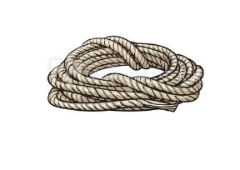

  - Fill in the blanks with the words from the box.
passport – comedy – uniform
1- You wear it at school. (………………….)
2- A document you need to travel abroad. (………………….)

- Orthography:
/ 5
  - Choose the correct missing letters:
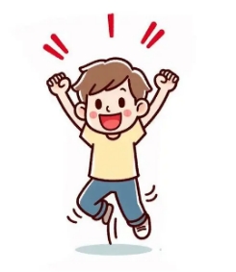  ex__ited |  | 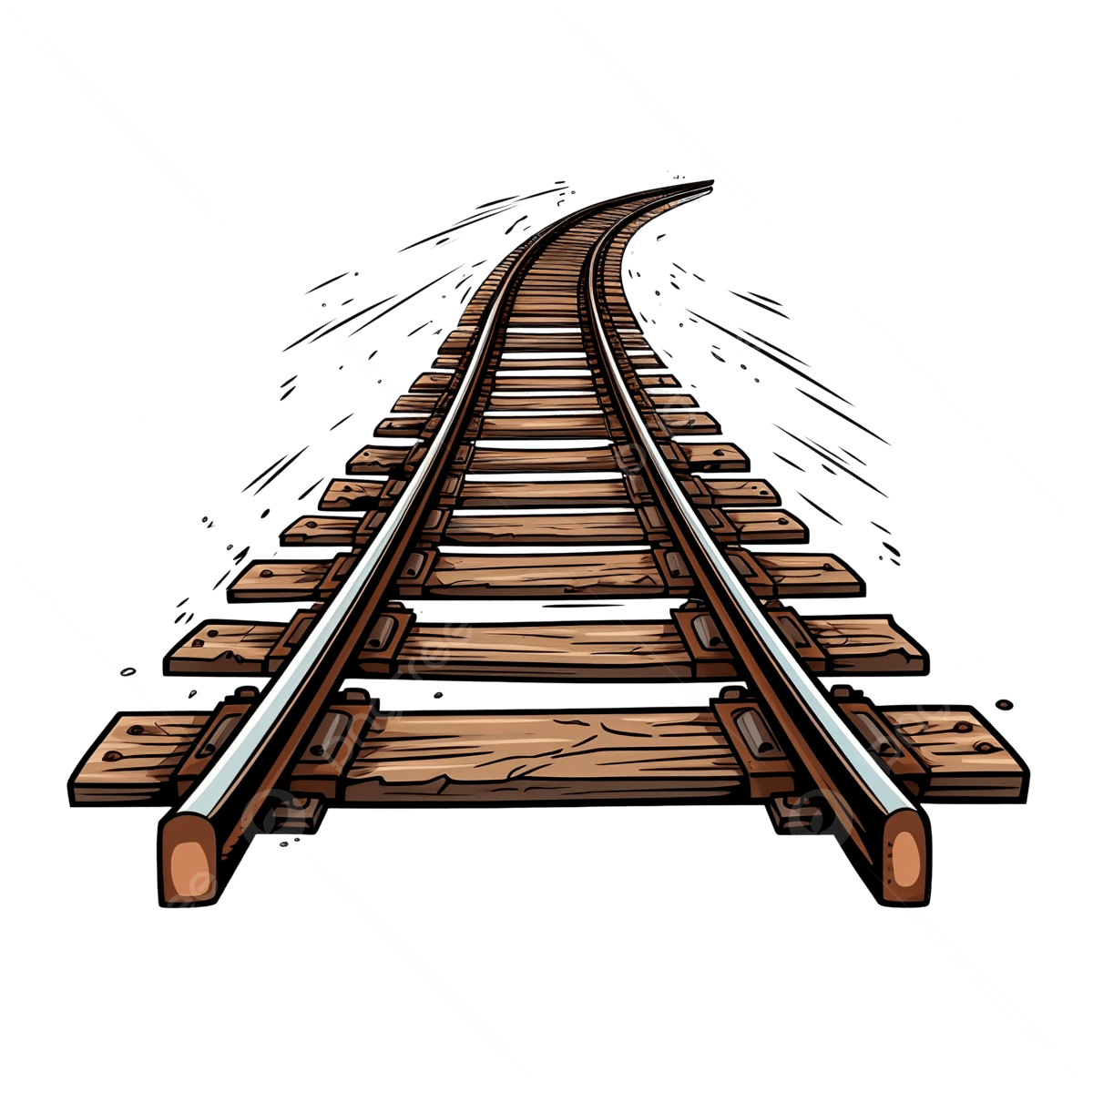  rai__road |  | 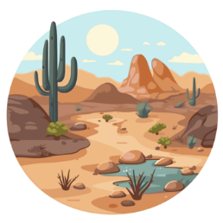  de__ert |  |   s__lk |  | 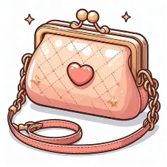  pur__e
c | s | r | l | s | z | e | i | s | c
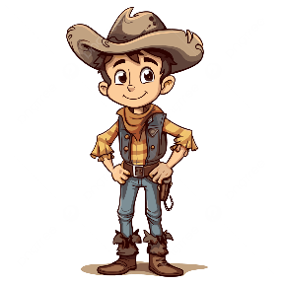  cow__oy |  |   ta__i |  |   a__ree |  | 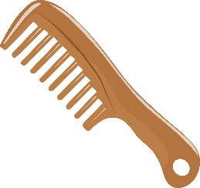  __omb |  | 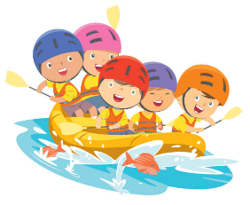  ra__ting
b | d | k | x | g | j | c | k | f | v

END OF QUESTIONS
BEST OF LUCK
Ms. Tahani AlGhamdi


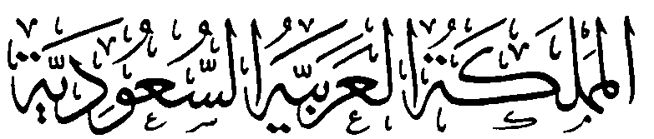
وزارة التعليم

الإدارة العامة للتعليم بمنطقة ......................
مدرسة .........................................
التاريخ: / / 144 هـ
الصف: السادس الابتدائي
الزمن: ساعتان
المادة: اللغة الإنجليزية

أسئلة اختبار الدور الأول للفترة الدراسية الثانية لمادة اللغة الانجليزية للصف السادس الابتدائي
للعام الدراسي 1447 هـ
الفصل الدراسي الثاني
عدد الأوراق : 4

اسم الطالبة : ........................................................................
رقم الجلوس : .........................................................................
اليوم : ...............................................
التاريخ : .......... / ........... / 144 هـ
الزمن : ...........................

 | Questions | Mark | Student's mark
Q1 | General Questions | 7
Q2 | Guided Composition | 7
Q3 | Reading Short Sentences | 7
Q4 | Grammar | 7
Q5 | Vocabulary | 7
Q6 | Orthography (spelling) | 5
Total : |  | 40
المصححة : ...............................................................التوقيع :.....................................
المراجعة : ...............................................................التوقيع :.....................................

معلمة المادة :

......................................................

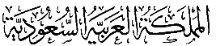
وزارة التعليم
الإدارة العامة للتعليم بمنطقة ......................
مدرسة .........................................
التاريخ: / / 144 هـ
الصف: السادس الابتدائي
الزمن: ساعتان
المادة: اللغة الإنجليزية

الدرجة رقماً |  | الدرجة كتابة |  | اسم المصحح | توقيعه | اسم المراجع | توقيعه
الدرجة رقماً | 40 | الدرجة كتابة | درجة فقط
اختبار اللغة الإنجليزية نهائي – الدورالاول – للصف السادس – الفصل الدراسي الثاني 1447هـ

7
- General Questions:
- What’s your favourite kind of story? |  | Yes, I would. I feel happy.
- What items do you need for fishing? |  | Go climbing in the mountains.
- Would you like to travel? How would you feel? |  | I need fishing rod for fishing.
- What activities do you do outside? |  | My favourite story is sci-fi.
- What clothes do you like to wear? |  | That’s a good idea.
- What kind of transportation have you used? |  | I like to wear my uniform.
- How about watching a movie? |  | I have used a car and a bus.
  - Match the questions with the correct answers:

7
- Guided Composition:
  - Use the following word bank to write a post about A Field Trip.
went animals plants interesting learned nice
___________________________
________________________________________________________________________________________________________________________________________________________________________________________________________________________________

7
III. Reading Short Sentences:
  - Read the sentences then match them with the correct pictures:
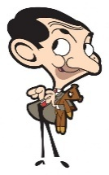 |  | 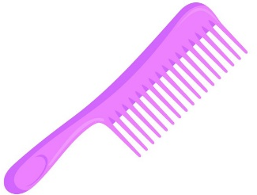 |  |  |  | 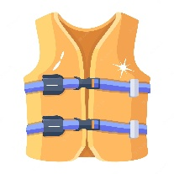
a- It is a comedy story.  b- It is a drama. |  | a- A comb made of plastic .  b- He was fishing. |  | a- The plane lands.  b- The plane takes off. |  | a- It is a life jacket.  b- It is a backpack.
 | 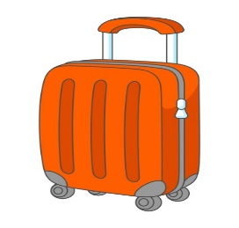 |  | 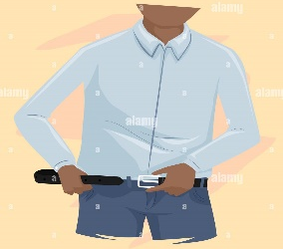 |  | 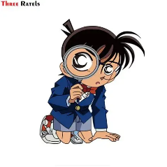
 | a- Hurry to the platform.  b- Put everything in a suitcase. |  | a- I wear a belt.  b-_Listen to your teacher |  | a- It is an animation.  b- It is a mystery movie.

- Grammar:
  - Choose the correct answer:

7
    - He was (watch – watched – watching) a movie.
    - We have (take – took – taken) a tour before.
    - They didn’t (see – saw – seeing) the snake.
    - How long ( has – have – is ) she liked rings?
    - I haven't found my suitcase ( yet – just ) .
    - She (was – were – are) singing in the musical.
    - Have you ( buy - buyed – bought ) a costume this year?

7
- Vocabulary:
  - Write the words under the correct pictures:
1- detective 2– rock climbing 3– tie 4- crown
5– traffic 6- platform 7– mountain biking

 |  | 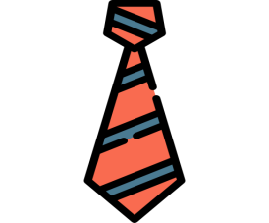 |  | 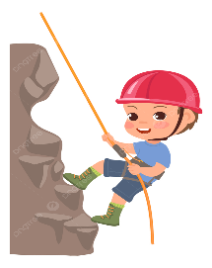 |  | 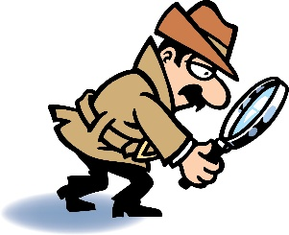
 |  |  |  |  | 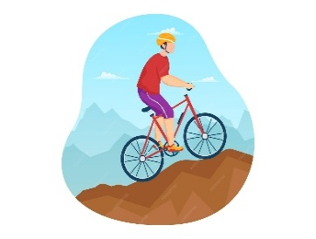
 |  |  | 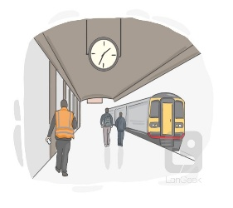

5
- Orthography:
  - Fill in the missing letters:

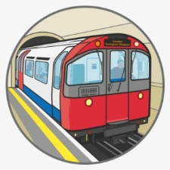  su__way |  | 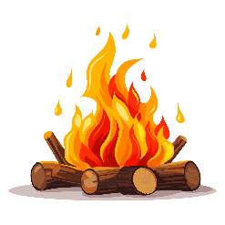  cam__fire |  | 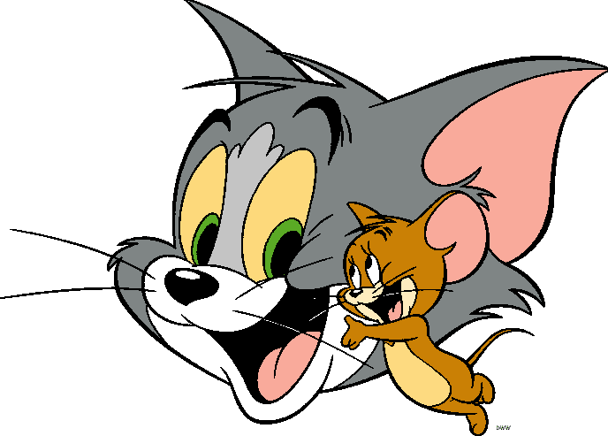  car__oon |  |   r _ ng |  | ta__i
b | k | p | u | d | t | m | i | l | x

